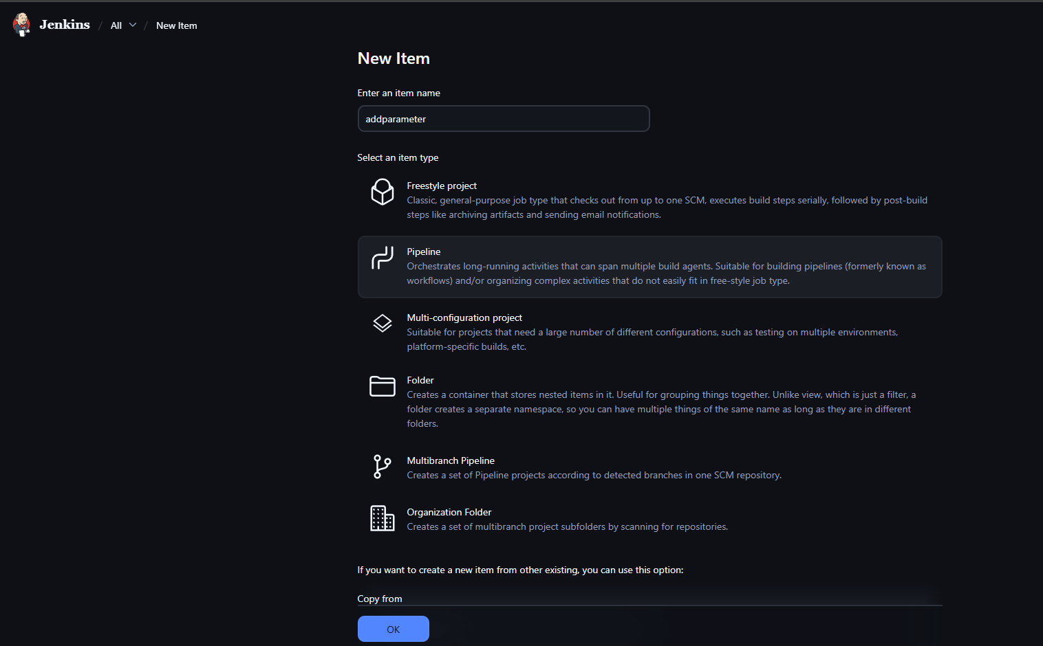





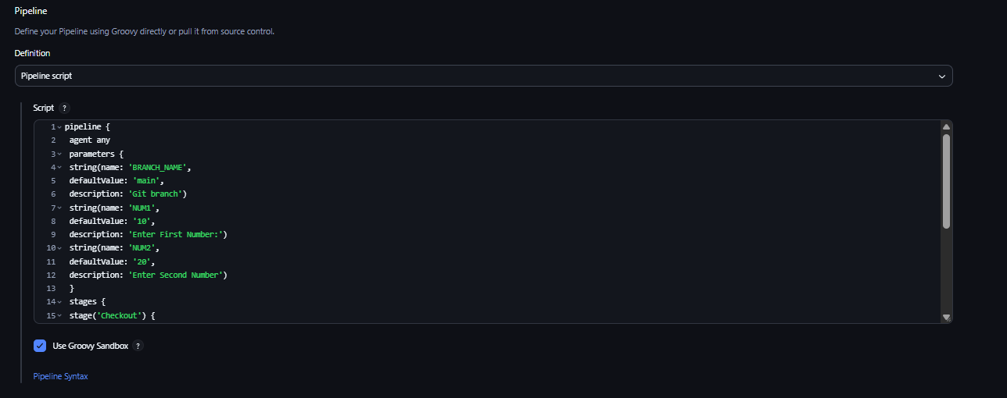



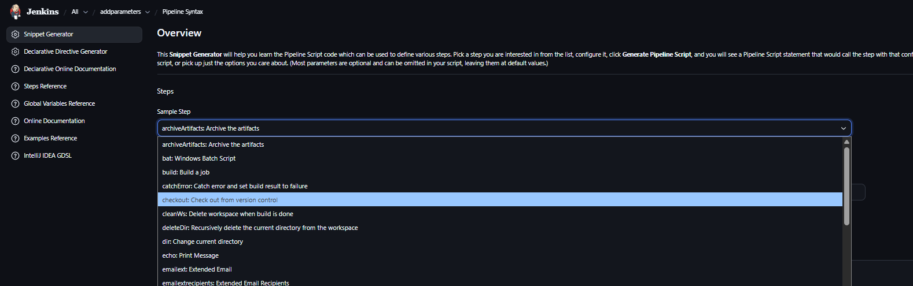

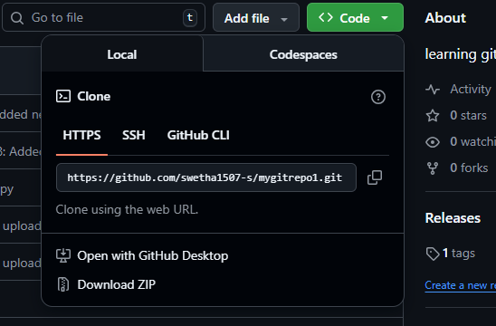

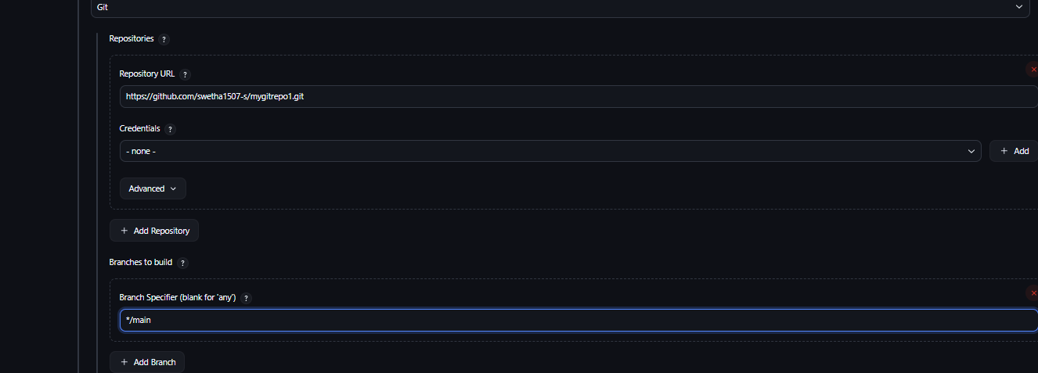

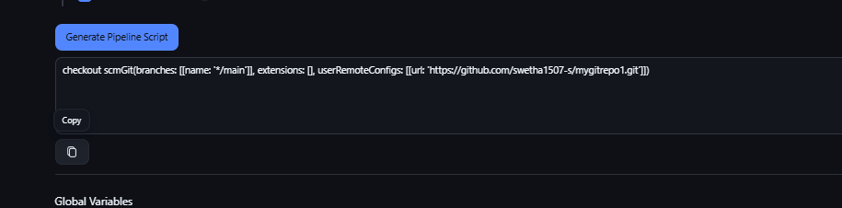

No need :

directly give repo url in url

pipeline script

pipeline {
agent any
parameters {
string(name: 'BRANCH_NAME',
defaultValue: 'main',
description: 'Git branch')
string(name: 'NUM1',
defaultValue: '10',
description: 'Enter First Number:')
string(name: 'NUM2',
defaultValue: '20',
description: 'Enter Second Number')
}
stages {
stage('Checkout') {
steps {
git branch: "${params.BRANCH_NAME}",
url: 'https://github.com/swetha1507-s/mygitrepo1.git'
}
}
stage('Addition Build') {
steps {
bat "python add.py ${params.NUM1} ${params.NUM2}"
}
}
}
}

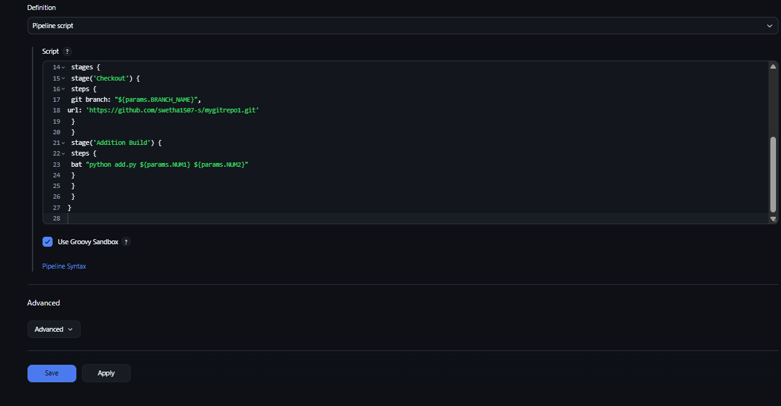
click save

